**Task 1 :Database Setup and Schema Design**

1. **Open Oracle SQL Developer** and connect using **SYS** credentials. Then, connect to the specific **User/Schema** within the database. *(This guide uses Oracle 11g as an example.)*
2. **To create a new User/Schema**, you must have **SYSADMIN privileges**, as this role is responsible for granting and revoking access. If you don’t have these permissions, contact your **SYSADMIN** to execute the required queries.
3. **Check your database version**, as this helps determine the features and syntax supported in your environment.

1. **Create the database schema** and **grant the necessary permissions** required to manage and access data within that schema.

1. Once the schema is ready, **connect to the LibraryDB schema** using its assigned username and password.
2. Next, **design an Entity Relationship (ER) diagram**. This diagram illustrates how entities (tables) relate to one another and serves as the blueprint for your database structure.
3. Identify Tables that are needed to store data. Based on Normalization rules then create **Entity Relationship Diagram.**

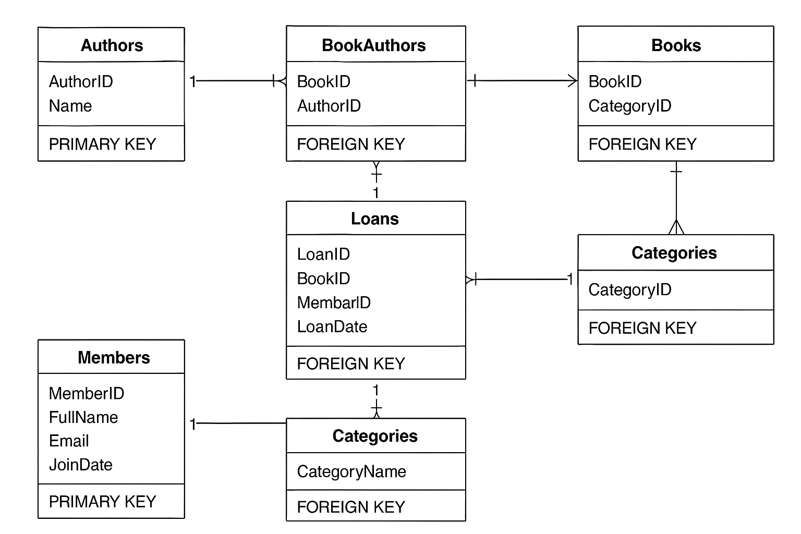

1. Create tables and Sequences( Insert Unique Values to Primary key Column Automatically).
2. For that we have to insert like ‘:new’ while inserting values into the column.
3. Otherwise, in high-level we can create Triggers For to automate this.
4. Use Constraints (Existing rules that allow the data into columns) while creating tables.

1. Sequences

1. TablesA screenshot of a computer

   AI-generated content may be incorrect.